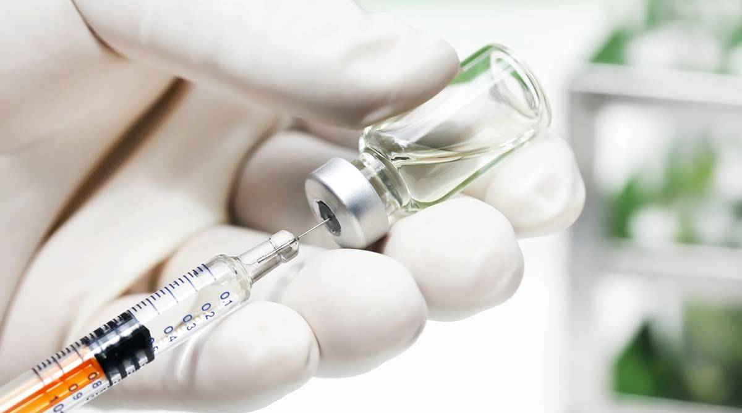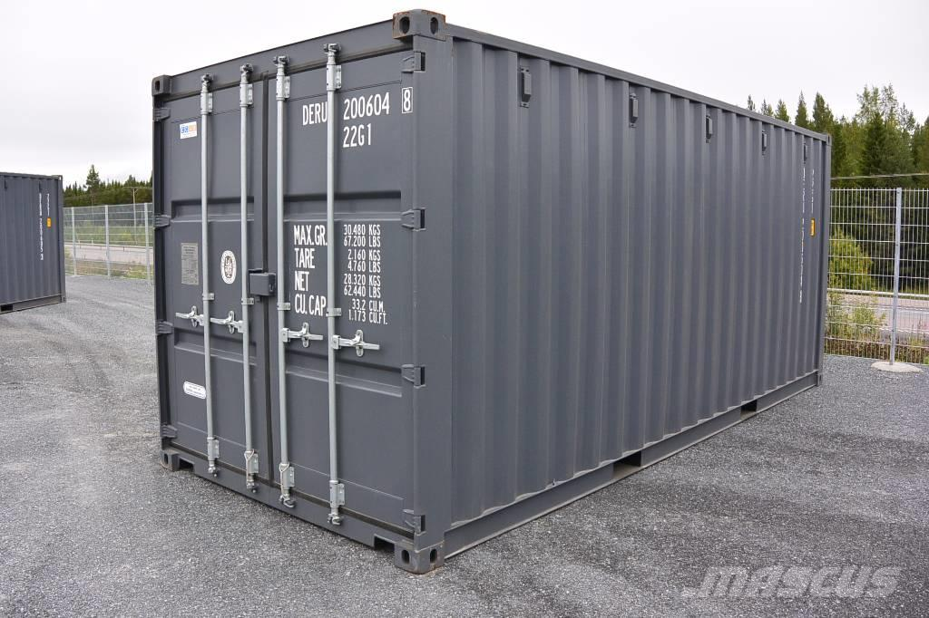
Shipping container
Modern Medicine
Of the 4 factors, which do you feel is more responsible for the improvement of the quality of life of people around the world.
Consider the uses, the aims, who can accesses, the impacts of, the benefits of, the negatives, the costs of the outcomes from the different factors. Can you consider different categories e.g social, economic, environmental and political impacts?
Aim for 400/500 words. Found this easy challenge yourself to pick 4 of your own items/factors and repeat the process.
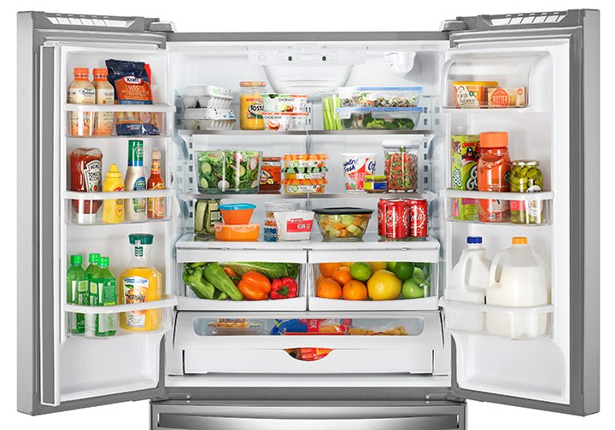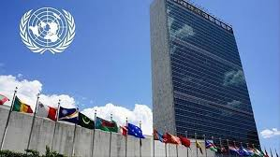
The United Nations
Modern refrigeration

