Year 12 letter

Dear parents and carers,

We would like to wish our students and their families a very happy Easter and Eid Mubarak to our Muslim families. Please find below a summary of our half term and plans for our Year 13 students’ final half term before study leave commences!

The next parent council meeting will take place on 30th April 4-5.30pm (rearranged from 27th March). All are welcome. Please email [baasixthform@bluecoat.uk.com](mailto:baasixthform@bluecoat.uk.com) to let us know if you are planning to join us.

Kind regards,

Ms A Wood

Attendance and punctuality

Our average attendance for the year has fallen slightly to 89.1%. This is below the national average of 91%, and far below our aspirations for students to have 96% attendance. Attendance is directly linked to outcomes, so it really is vital for students’ futures that they are in lessons, and we appreciate all of your help with this.

Dress code

The weather is going to start warming up! A reminder that we have do have a dress code and students may be required to return home to change if they are not adhering to this code.

* Flip flops or sliders are not to be worn for health and safety reasons
* Tops must cover the midriff (stomach area)
* Trousers/jogging bottoms or jeans must be worn pulled up to cover underwear.
* Shorts, dresses and skirts to be no shorter than mid-thigh
* Hats and coats to be removed in class
* Lanyards to be worn at all time

Rewards

Students with the highest number of positive credits were celebrated this half term with vouchers. Spring 1’s rewards will be invited to attend a rewards trip early next half term.

A reminder that students lose credits for lateness to lessons, not attending homework club sessions and will not be invited to share in our rewards programme if they have an unserved detention for missing 2 x morning registration sessions or truanting our Friday tutor period.

RSHE

Having focused this half term on the university process, next half term we will support students in considering higher and degree apprenticeships. When asked earlier this year, a large proportion of our students indicated that they were considering pursuing an apprenticeship (see below), so it is important to us that we offer these students the same level of support as our students progressing to Higher Education.

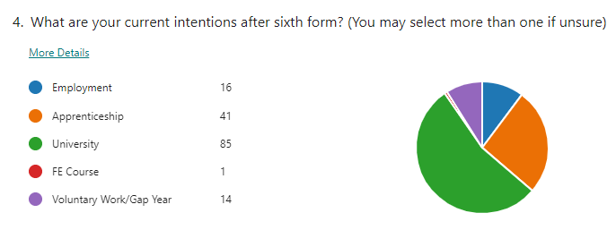

Theme: Alternative Pathways – Exploring Apprenticeships and Employment Options Post 18

* 19th April – An Intro to Apprenticeships
* 26th April – External provider Not Going To Uni; An Insight into Different Apprenticeships
* 3rd May – Careers in the Civil Service
* 17th May – Setting up Your UCAS Account!
* 24th May – Personal Statement Workshop

These sessions are covered during our tutor period on Friday 11.30-12.30pm and attendance is compulsory.

Careers and Employability: Work Experience

We will hold sessions this half term for students without work experience. We are committed to every student having an experience of the workplace before the end of year 12.

On Wednesday 3rd July all year 12 students will have a mock interview with a local employer. If you would like to encourage your employer to be involved, or could offer support yourself, please sign up using this QR code:

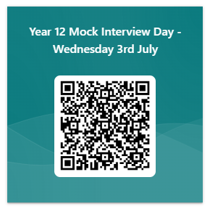

Enrichment

Our students’ wellbeing is important to us, and one of the best ways they can look after their mental health is by being active either physically or by actively pursuing an interest. We have updated our webpage with our full programme. Please encourage students to consider how they might get involved.

<https://www.bluecoatsixthform.co.uk/personal-development/enrichment-programme/>