Year 12 letter

Dear parents and carers,

I hope this letter finds you well.

Please find below a summary of the half term just gone and plans for the upcoming Summer term.

I hope you have an enjoyable Easter break.

Kind regards,

Ms A Wood

Attendance and punctuality

Our average attendance for the year group sits at 90.7%. This is below our aspirations for students to have 96% attendance. Attendance is directly linked to outcomes, so it really is vital for students’ futures that they are in lessons, and we appreciate all of your help with this.

Dress code

The weather is starting to warm up! A reminder that we have do have a dress code and students may be required to return home to change if they are not adhering to this code:

* Flip flops or sliders are not to be worn for health and safety reasons
* Tops must cover the midriff (stomach area)
* Trousers/jogging bottoms or jeans must be worn pulled up to cover underwear.
* Shorts, dresses and skirts to be no shorter than mid-thigh
* Hats and coats to be removed in class
* Lanyards to be worn at all time

Rewards

The top 25 students with the highest number of positive credits were celebrated this half term with pizza and a film. Spring 2’s rewards will be invited to participate in a rewards activity early next half term.

A reminder that students gain credits for positive points earned through effort in lessons, participation in enrichment and wider involvement in the sixth form community and 100% attendance. Students lose credits for low attendance, poor punctuality, negative behaviours and missing homework deadlines.

RSHE

This term saw a focus on next steps, including developing students' knowledge of apprenticeships and understanding of the university process. Next half term we will support students in beginning their university journey, starting with looking at using Unifrog for applications and registering with UCAS.

Careers and Employability: Work Experience

We will hold sessions this half term for students without work experience. We are committed to every student having an experience of the workplace before the end of year 12.

On Wednesday 2nd July all year 12 students will have a mock interview with a local employer. If you would like to encourage your employer to be involved, or could offer support yourself, please sign up using this QR code:

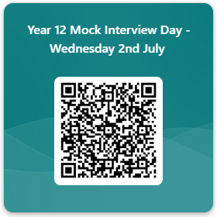

Preparations for summer mock exams:

Year 12 Summer Mock exams start in the afternoon of Wednesday 18th June, with study leave commencing on Thursday 19th June. All exams will take place in the Lecture Theatre in the Sixth Form Building. Morning exams will commence at 9am and afternoon exams, 1pm. The exam timetable will be shared with students in due course.

Results from these exams will be available to view on Go 4 schools on Friday 11th July.